Contents

Introduction 2

Getting to the Calendar 2

Using the Calendar 3

Selecting the date 3

Choosing the facility 4

Choosing the provider 5

Choosing the display of the calendar (Day, Week or Month) 6

Setting appointments 7

Cancelation of an appointment 10

Searching for appointments 11

Printing the Calendar 12

Creating appointment from the patient demographics 13

Scheduling the in and out time of the Provider 14

Handling Multiple Location color coding 17

Duplicating an Appointment 19

Calendar Settings 22

Disable calendar 23

Restricting the facility to a user 24

Calendar Starting/Ending hour 27

Appointment display style 28

Providers see entire calendar 29

Auto-Create New Encounters 30

Appointment/Event color 30

Categories 31

Category limits 33

Disable the calendar for a specific provider 35

Choose the calendar UI 36

# Introduction

The Calendar helps the ZH OpenEMR user to maintain working hours of Facility/ Provider. The calendar divides the working hours into time slots of fixed time enabling the staff to schedule the facilities care providers. The below documents will show the user how to manage the settings and use the calendar to attain maximum efficiency.

# Getting to the Calendar

Clicking on the calendar tab shown below will get you to the calendar screen

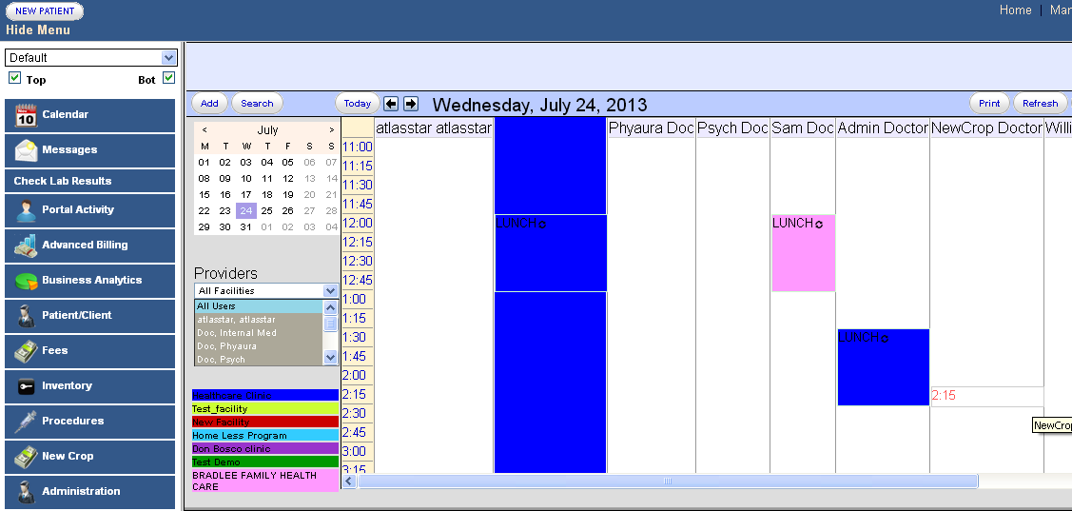

# Using the Calendar

## Selecting the date

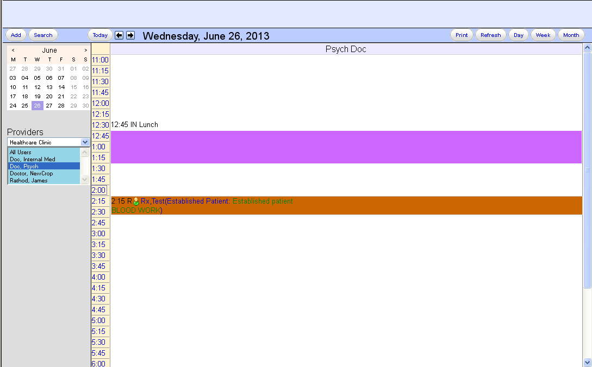

Marked in the figure above is the area wherein we can select the required date. We can use the arrows on the top left hand and right hand corner in the marked area to navigate to the previous and following months respectively.

## Choosing the facility

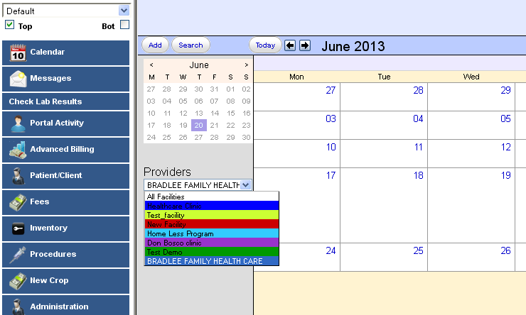

The dropdown marked above, helps us to choose the facility for which we want to view the calendar. From the drop down we can choose the facility according to our choice.

## Choosing the provider

After choosing the facility, we can choose the providers for whom we want to view the calendar.

a) We have the option of choosing a single provider under a facility, by clicking on the provider name.

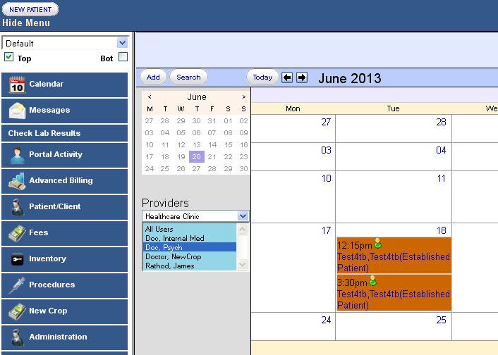

We can choose multiple providers, by pressing down the ctrl button and clicking on more than one provider.

We can click on ‘All Users’ view the calendar of all the providers in that facility at the same time.

## Choosing the display of the calendar (Day, Week or Month)

We can choose to display the calendar in the Day, Week or Months view. This can be done using the options shown below

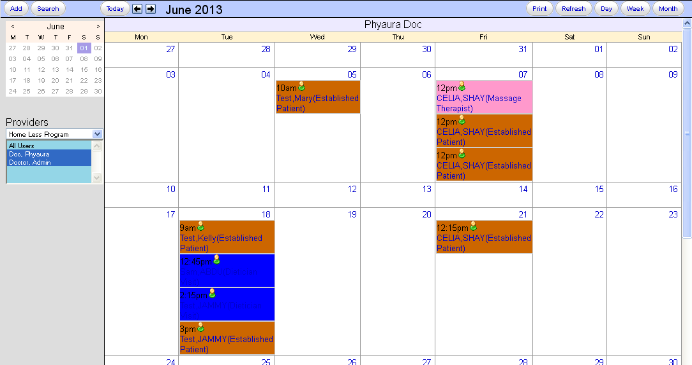

## Setting appointments

A patient can set appointments on the calendar or the provider can set his calendar using the ‘Add’ option shown below or by clicking the time slots, shown below.

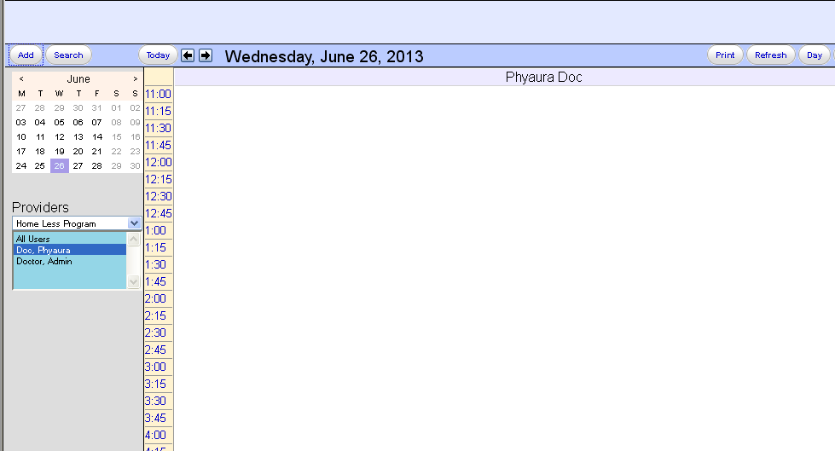

On clicking the ‘Add’ option we get the following screen

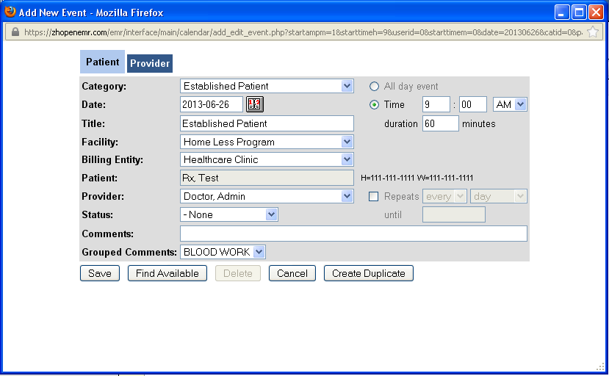

On the screen shown above, a patient can book an appointment by filling up the details as pertinent to the patient.

The fields that are to be filled are

Category: - It defines the category to which the patient belongs. It would be defined in the categories in ‘Admin->Others->calendar’ tab.

Date: - Date of appointment.

Title: - By default it is the category. We can edit it according to our requirement.

Facility: - The facility in which appointment is set.

Billing entity: - The entity to which we will bill the encounter.

Patient: - Patient name.

Provider: - The provider name.

Status: - Status of appointment can be set here. The’@ Arrived’ status automatically creates an encounter.

Comments: - We can enter a comment.

We can also set the time and duration and repetition details for the event.

The ‘Find Available’ tab, finds the times that the provider is free for appointments to be booked.

The ‘Create duplicate’ tab enables a similar appointment to booked, on a different date, with the same entries.

On clicking the save button, the details of the appointment appear on the calendar.

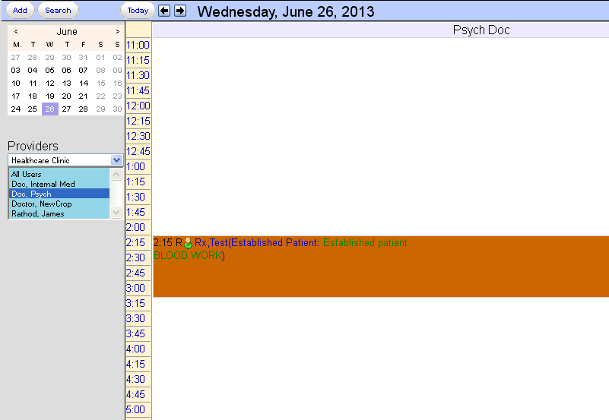

By clicking on the patient name (shown with the white arrow) on the appointment on the calendar we can go to the patient chart.

We can also set the calendar in the provider’s perspective by clicking on the ‘provider’ tab shown below.

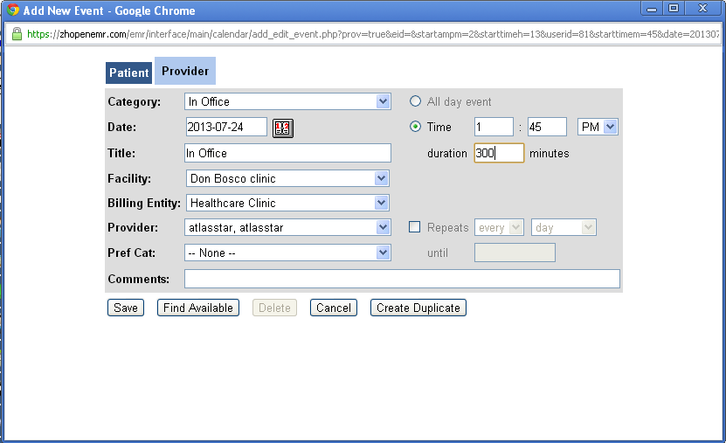

On clicking the save button, the details of the appointment appear on the calendar.

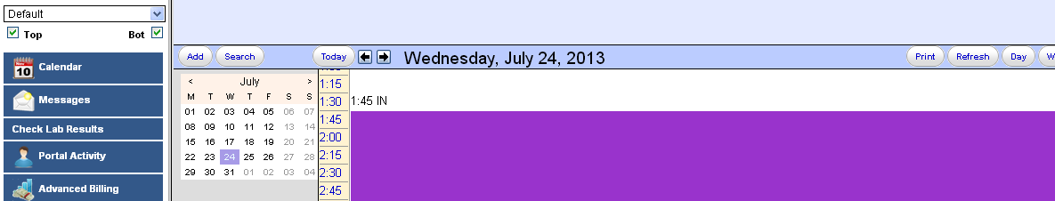

## Cancelation of an appointment

Click on the time shown on the appointment being set on the calendar.

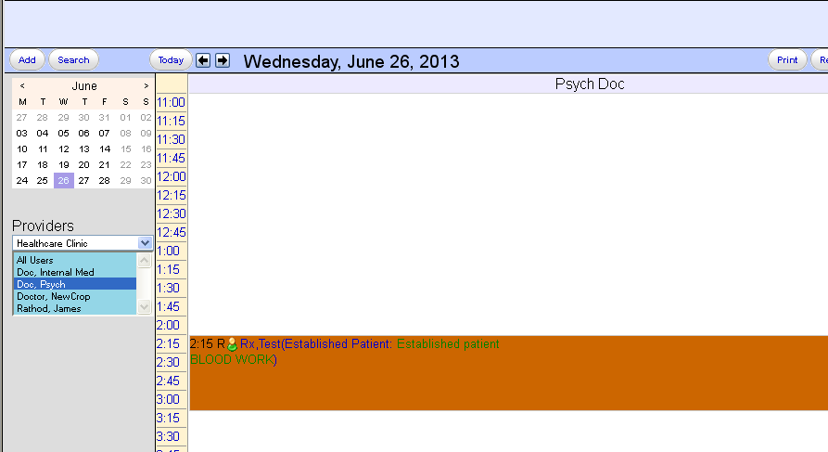

Now the following screen appears. Now click on the ‘Delete’ button to cancel the appointment.

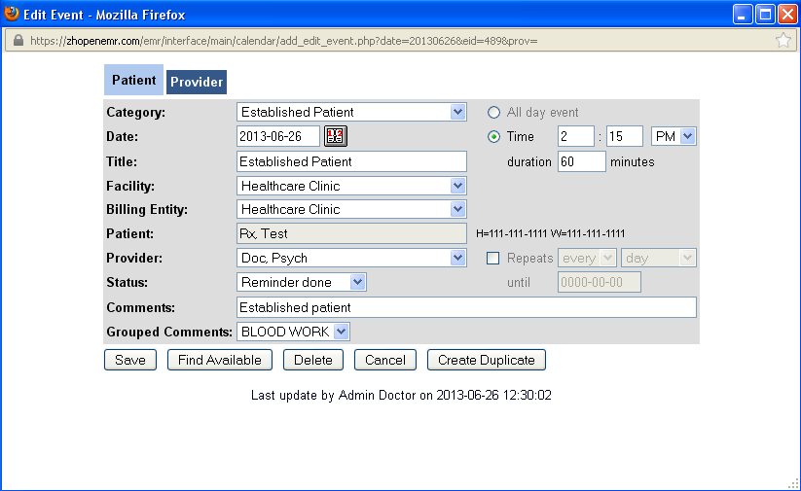

## Searching for appointments

We can do a customized search of the appointments using the ‘search’ button.

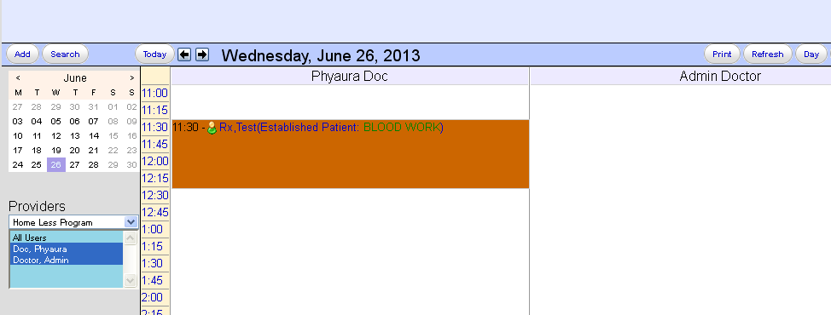

On clicking the search button we come to the following screen.

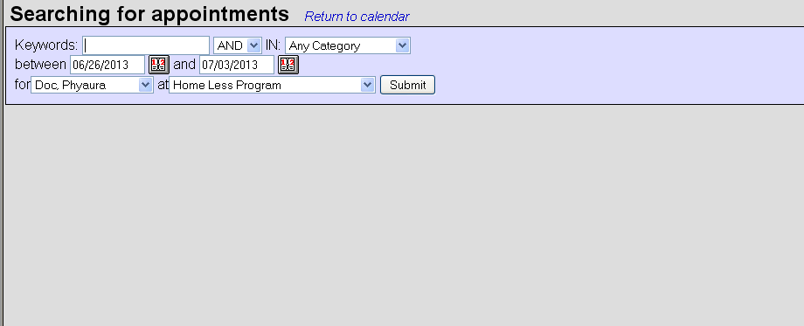

You can customize your search by filling the details as needed.

## Printing the Calendar

We can print the calendar on paper using the ‘print’ option shown below.

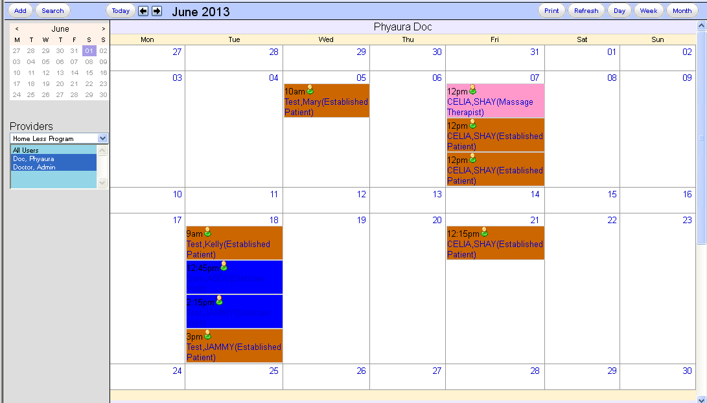

## Creating appointment from the patient demographics

We can create an appointment from the patient demographics page by clicking on the ‘Add’ button shown below.

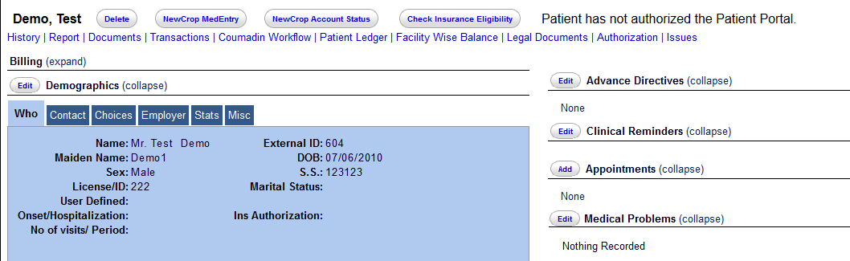

On clicking the ‘Add’ button we get to the appointment scheduling screen.

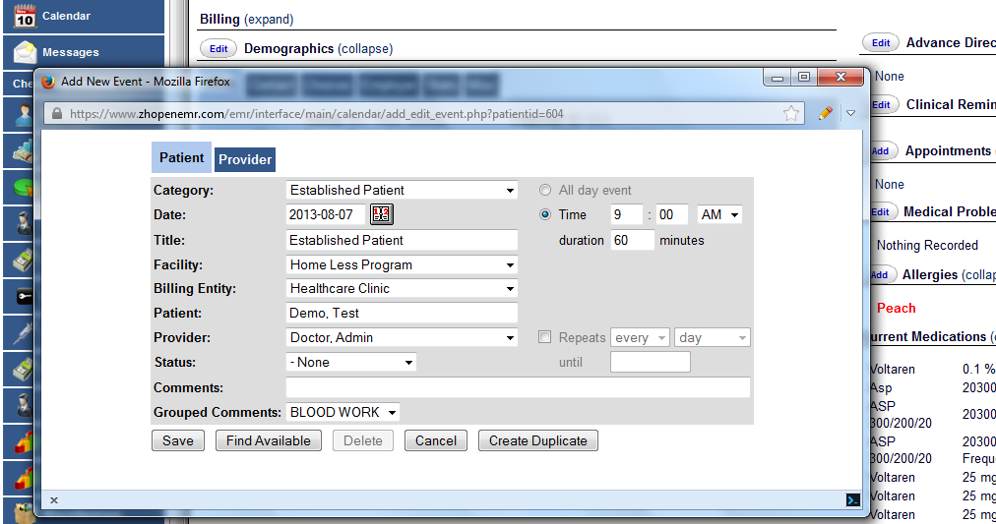

## Scheduling the in and out time of the Provider

To enter the in time for a provider, click on the time (For example we should click on 10:00), so as to get to the page where we book appointments. Then click on the ‘provider’ tab.

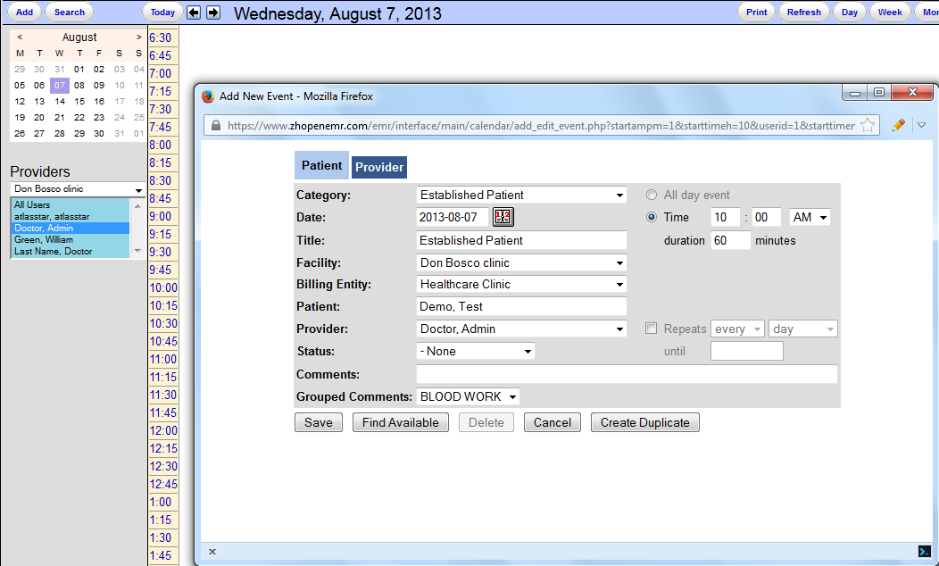

Here we can set the category to ‘In office’ and the duration also. Then click on ‘save’.

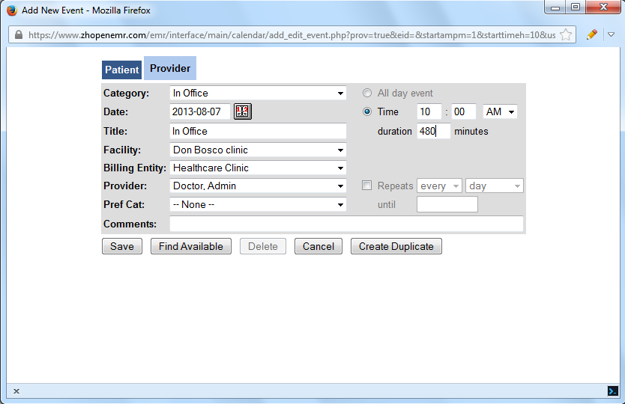

Now if we go to the calendar screen we can see that the ‘IN’ time has been marked.

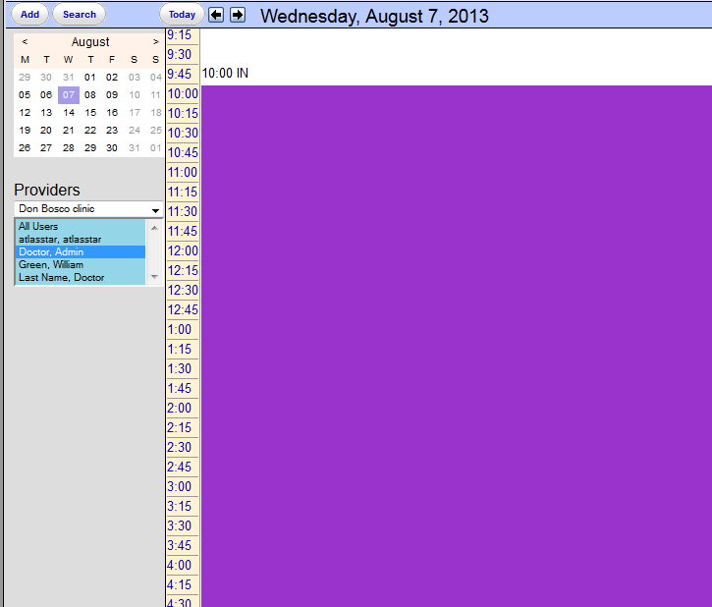

Similarly we can also mark the ‘OUT’ time

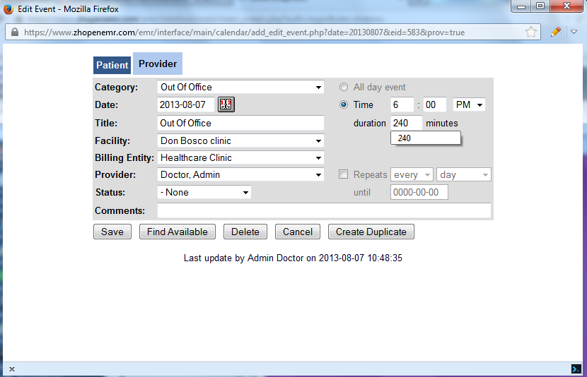

Now we can see that the out time is set accordingly.

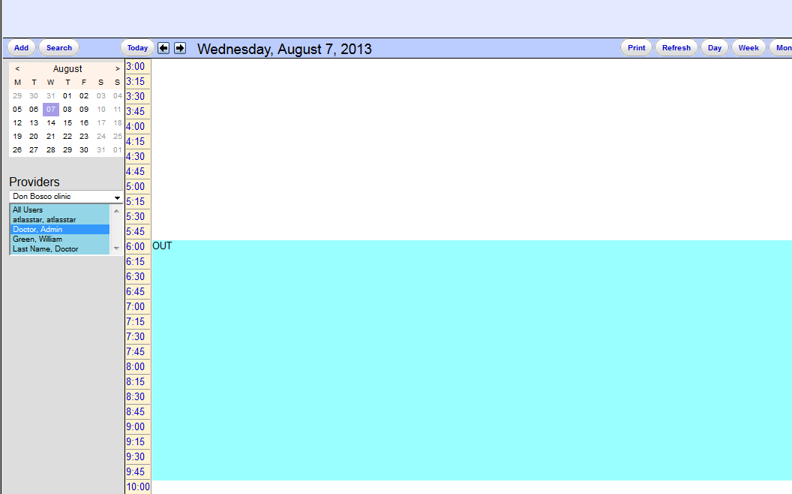

## Handling Multiple Location color coding

The color coding for the facilities can be set by going to the ‘Administration -> Facilities’.

In the facilities section we need click on the facility name

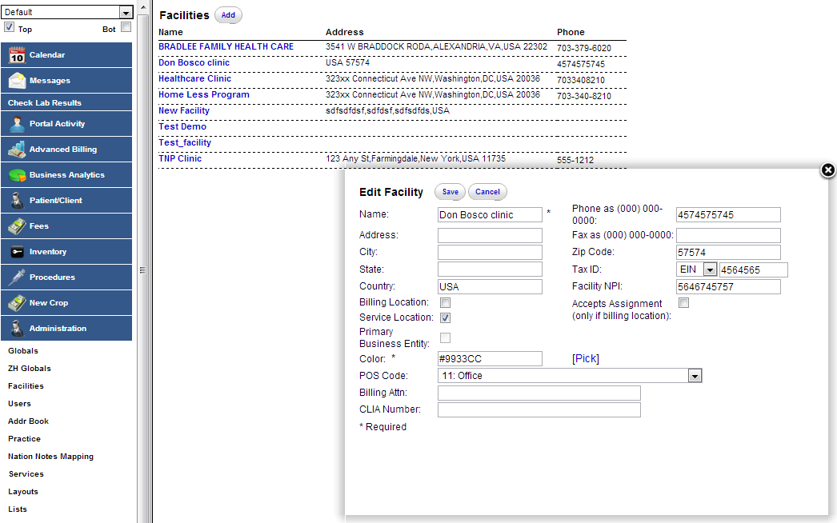

Now we click on ‘pick’ and we get to choose the color for the facility. Once the color is chosen, we click on the save button to retain this color.

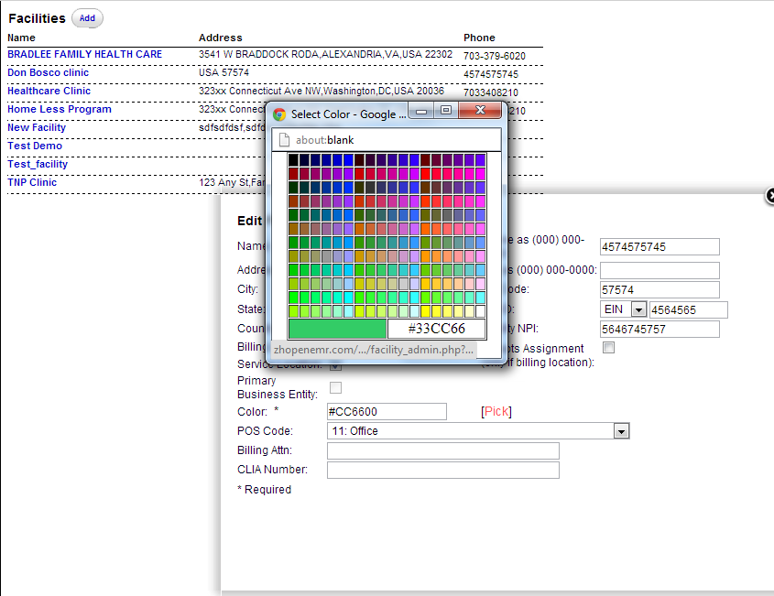

Now if we go back to calendar tab, we can find that ‘Don Bosco clinic’ is represented by the same color.

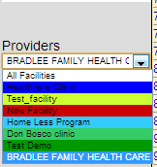

## Duplicating an Appointment

This feature allows us to duplicate an appointment that is already present in the calendar.

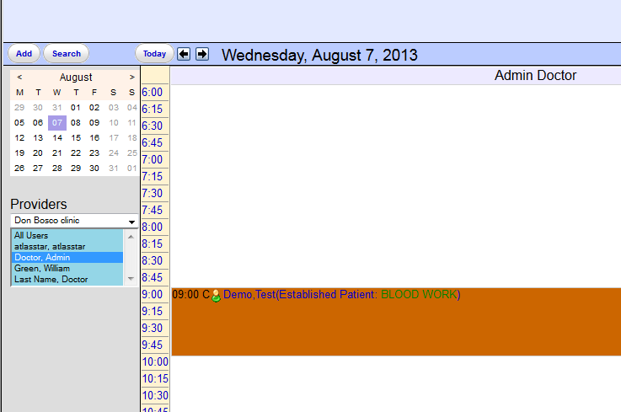

We can double click on the time of the appointment, shown in the figure. Then we get to the appointment screen.

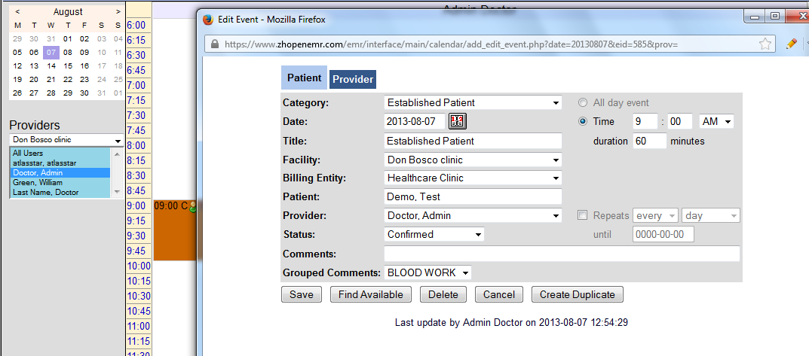

In the appointment screen we can change the date and the time or any other details and click on the ‘Create Duplicate’ button and a duplicate appointment would be created. In this case the date, the time and duration has been changed.

Date from ‘2013-08-07’ to 2013-08-08’. Time from ‘9 AM to 12 AM’. Duration from 60 to 90 minutes.

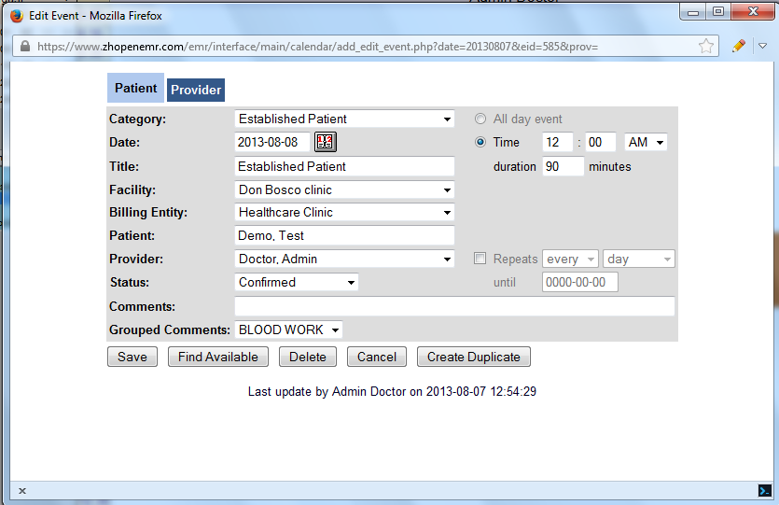

Now we can see that the duplicate appointment is created for the new date, time and duration.

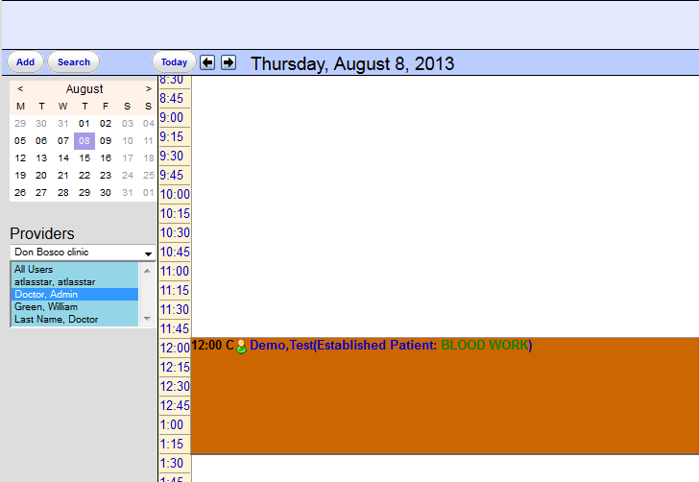

# Calendar Settings

We will look at some of the features of the calendar to be controlled by the admin. First we will look at the settings in the path ‘Administration -> Globals -> Calendars’.

How to get to this path

We can get to this path by clicking on the ‘administration’ tab. Under the administrator tab, we click on the ‘Globals’ tab and under the globals, we have to choose the ‘calendars’ option as shown below.

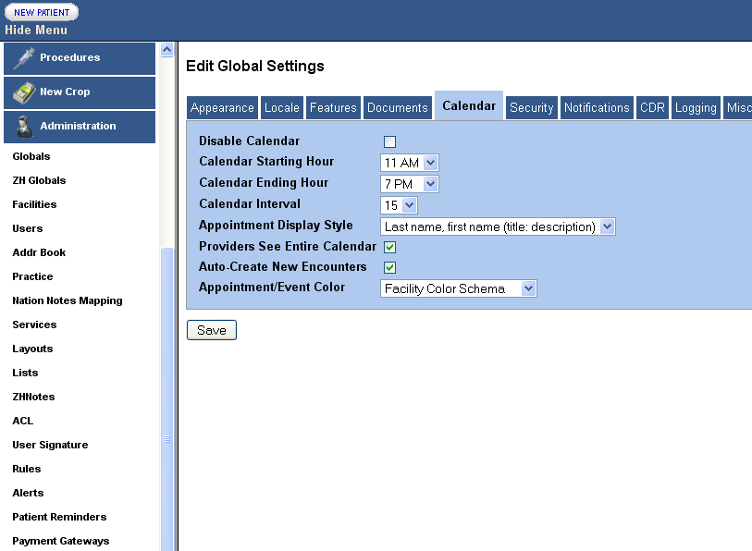

## Disable calendar

By checking the box next to the ‘Disable Calendar’ we can remove the calendar tab shown using the arrow.

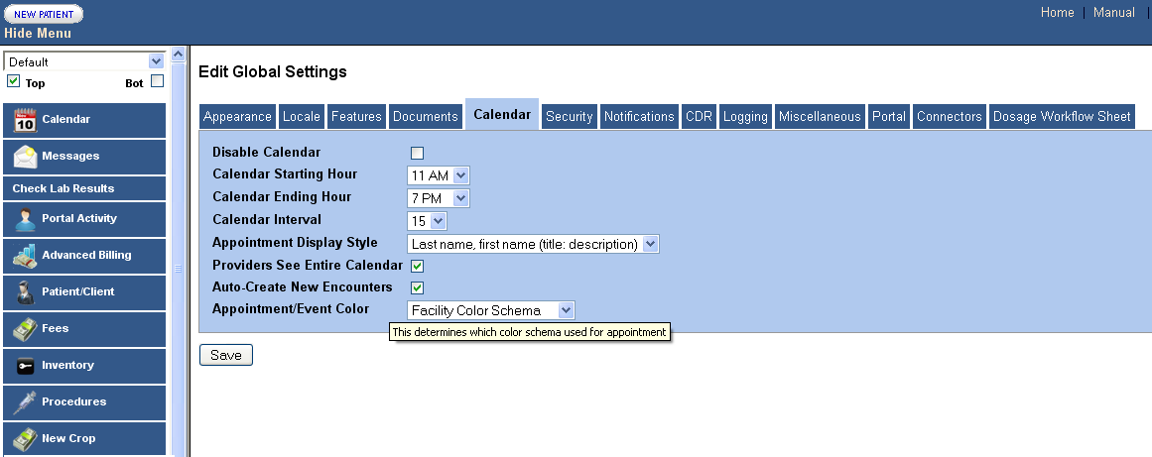

Once it is checked and we hit the save button, the main screen would be without the calendar tab as shown below.

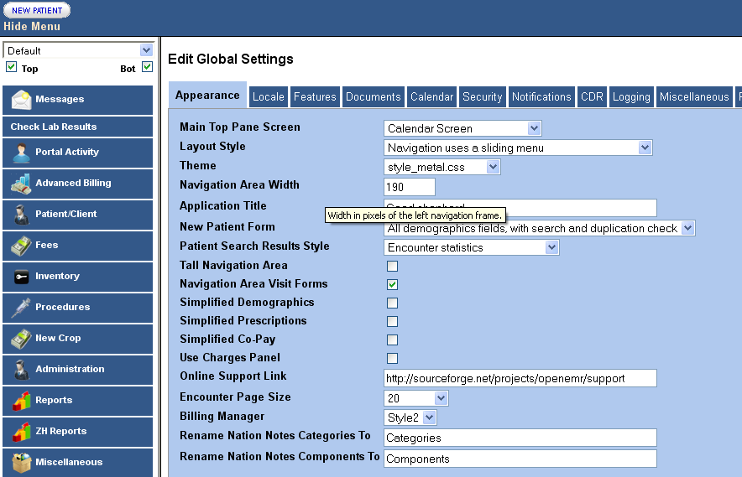

## Restricting the facility to a user

First we go to the path ‘Administration -> Globals -> Features’. In this we have the ‘Restrict users to Facilities’ option.

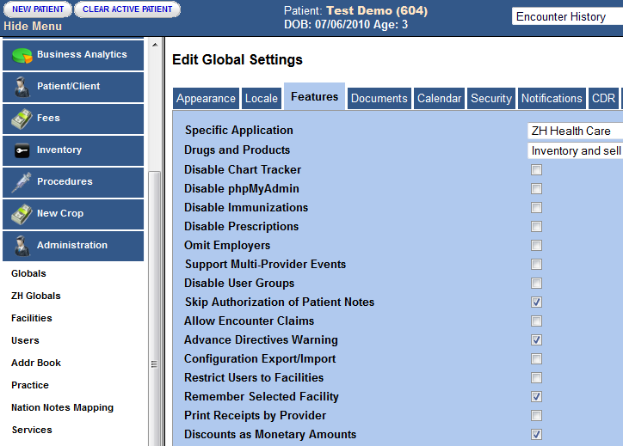

When we check the ‘Restrict Users to Facilities’ option and save it, we will be able to restrict the number of facilities which a user gets access.

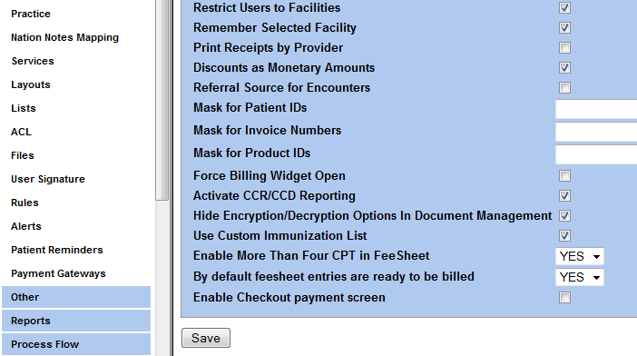

Next we go to the ‘Administration -> Users’. Here we select a user. In this case we have selected the ‘admin’ user. In the ‘Schedule facilities’, we get the option to select the various facilities to which the ‘admin’ user will have access to.

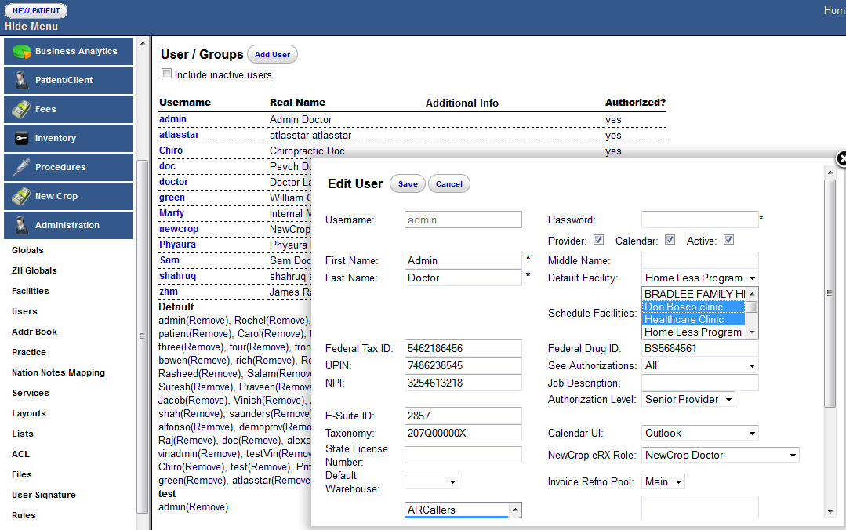

In this case we have restricted the user ‘admin’ to Don Bosco clinic and Healthcare Clinic. Click on the ‘save’ button.

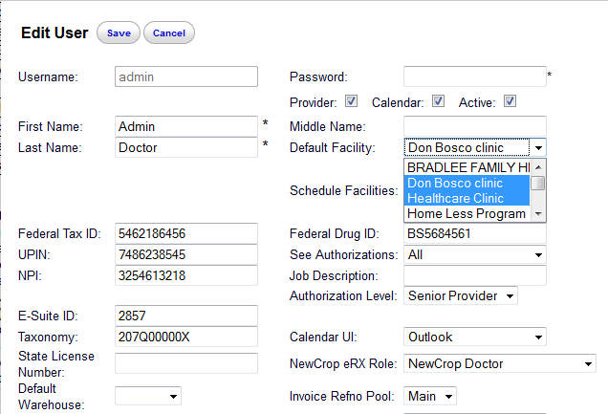

Now when we go to the calendar screen for the ‘admin’ user, we can see that this user has only 2 facilities in the calendar.

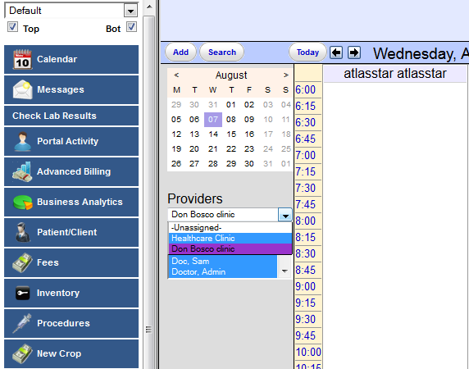

## Calendar Starting/Ending hour



By setting the above timings, we can set the start time and end time for the calendar for a particular day.

**Calendar Interval**



We can set the interval on the calendar ‘time slot’ shown in the main calendar screen by changing the settings in the drop down box shown above.

## Appointment display style

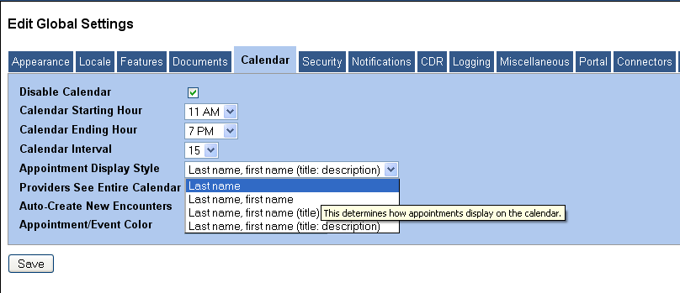

The appointment display style can be set using the drop down shown above. Using this we can decide the display on the calendar when an appointment is set by a patient on the calendar screen.

## Providers see entire calendar



By checking this we can make the calendar of all the providers visible to every other provider. If this option is unchecked, then a particular provider see’s their own calendar, only.

## Auto-Create New Encounters



If this option is checked, then when the status of a patient is changed to ‘@-Arrived’, an encounter with that patient is automatically created.

## Appointment/Event color

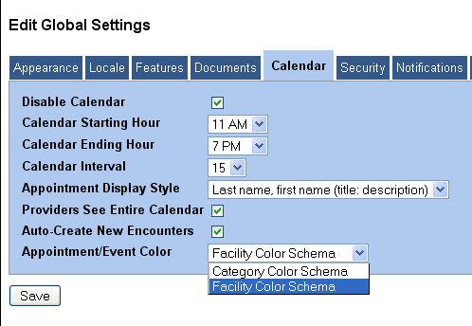

By choosing either the ‘Category Color Schema’, the appointments that are set on the calendar would be seen in the color coding of the patient category. In the ‘Facility Color Schema’, the appointments would be seen in the color coding of the ‘facility’.

Let us look at the settings in the path **‘Administration -> Others -> Calendar’**.

How to get to this path

We can get to this path by clicking on the ‘administration’ tab. Under the administration tab, we click on the ‘Others’ tab and under the others, we have to choose the ‘calendar’ option as shown below.

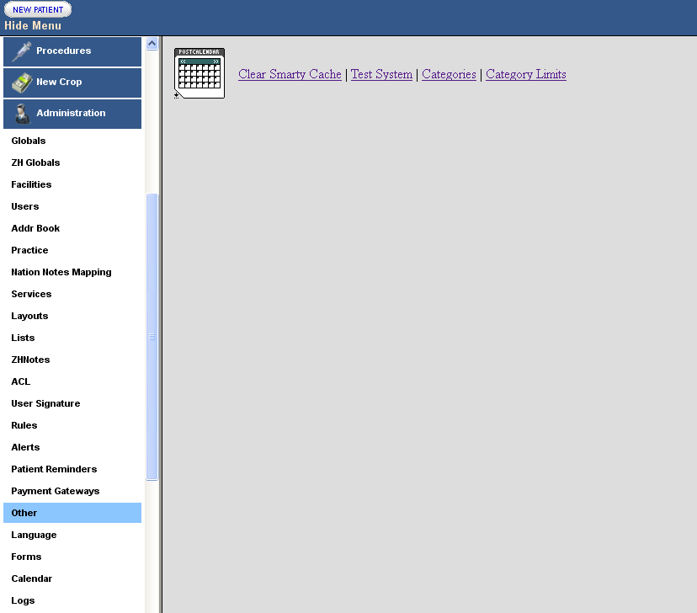

## Categories

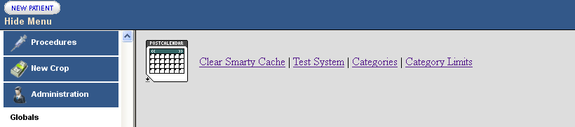

By clicking on the ‘categories’ tab, we would see the screen for creating and editing the categories for the patient and provider appointments.

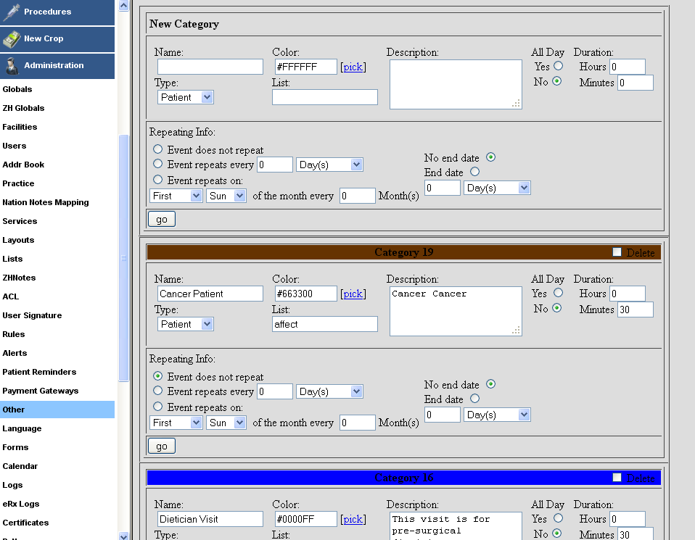

Description of the various settings while creating a category.

**Name**: - Define the name of the category.

**Color**: - Here we can pick the display color of the category.

**All day**: - This option is there to decide whether the appointments of this nature would last all day or not.

**Duration**: - This option is to decide the duration for which appointments under this category would last.

**Type**: - Decides whether the category is for the patient or provider. We can select it using the drop down.

**List**: - Allows us to create ‘grouped comments’ for a category.

**Repeating info**: - Set the details pertaining to category repetition. An Example could be, ‘lunch’ category repeating from Monday to Friday for 2 years.

## Category limits

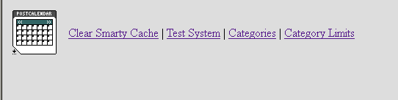

On clicking the category limits, we see the following screen

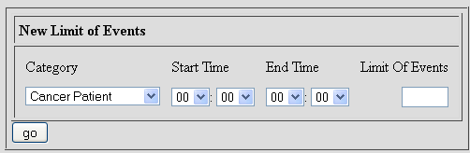

Choose the category.

Then choose, what should be the start time and end time, in which the category should lie.

Let us look at the settings in the path **‘Administration -> Users’**.

How to get to this path

We can get to this path by clicking on the ‘administration’ tab. Then click on the ‘Users’ tab.

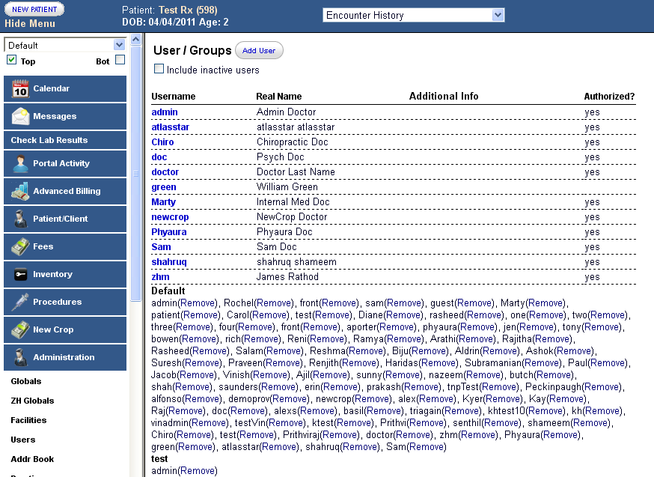

## Disable the calendar for a specific provider

We can disable the calendar for a specific provider. In this case, let us take the user ‘atlasstar’. So click on ‘atlasstar’ shown below.

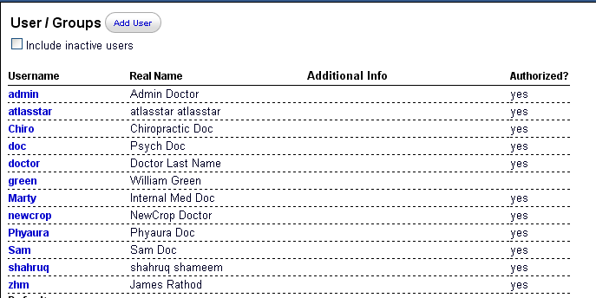

On clicking on ‘atlasstar’ we get the following screen and uncheck the calendar option. This will deactivate the calendar for the user ‘atlasstar’.

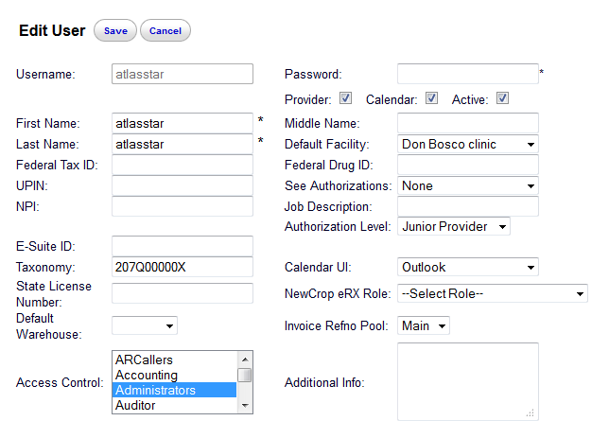

## Choose the calendar UI

We can choose the calendar UI for a user, by choosing from the following dropdown, after choosing a particular user.

